**AutoMate App README (APK)**

**Installation**

1. **Download APK:**
   * Click on the APK file and download it onto two Android mobile phones.
2. **Allow Unknown Apps:**
   * During APK installation, allow unknown apps to be installed on the device if prompted.
3. **Device Compatibility:**
   * Ensure that the mobile devices are Android, preferably newer versions. The app may not work on older Android versions.
4. **Security Recommendation:**
   * After installation and testing, consider disabling permission to install unknown apps for improved device security.

**Setup**

1. **Permissions:**
   * Accept all required permissions, including access to the camera and notifications.
   * The app requires camera and notifications to work properly.
2. **Network Requirements:**
   * The app will not work on university Wi-Fi (unable to connect to the server); use a home network or mobile data.
3. **Account Creation:**
   * Run the application, enter your mobile number and password.
   * If no account exists, click on "Sign Up" and create an account.
   * Use the following test login for the second device (in case you do not have a second number):
     + Username: +971 00 123 4567
     + Password: Test@
   * Log in with the created accounts on both devices.
4. **Navigation:**
   * The home screen has 5 buttons and a bottom navigation bar with 2 tabs (home screen and settings).

**Rewards and Sell**

* The 'Rewards' and 'Sell' buttons are for future implementation and are demo-only.

**Basic Working of the App**

**Get My QR Code**

1. Click 'Get My QR Code.'
2. Save the QR code to the gallery.
3. Print, trim, and stick the QR code on the car windshield.
4. Test by opening the app on a second phone and scanning the code.

The QR code must be stuck on the windshield of the car so that if there is any tint, it will not cause any visibility issue for users and the scanner. For testing purposes, use the QR code displayed on the second device (from a different account).

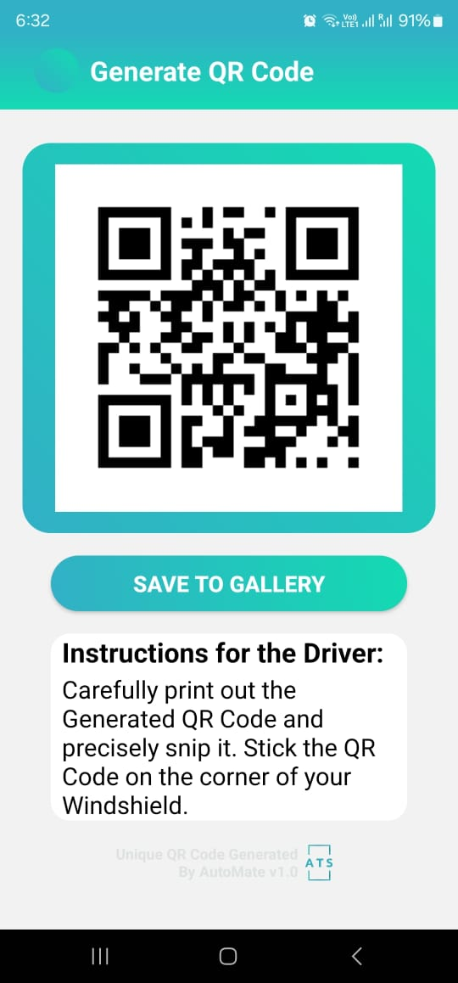

**Scan QR Code**

1. Press 'Scan QR Code.'
2. Use the QR code scanner to scan the code.
3. In low light, use volume buttons to control the flashlight.
4. After successful scanning, choose a scenario from the five displayed.
5. Once the scenario is selected, a confirmation page will pop up.
6. Click on send and the second phone should receive a notification.

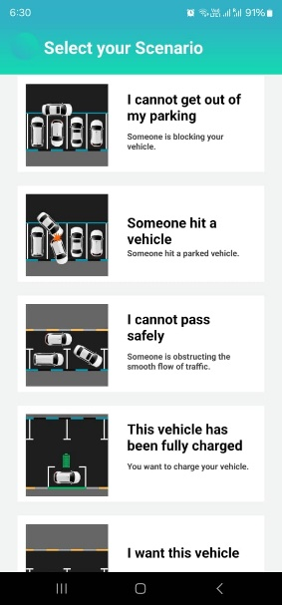

**My Messages**

* View all received messages and notifications on this page, including date and time.

**Notes**

* **My Rewards and Sell My Car:** For demo purposes only.
* **University Wi-Fi:** App will not work on university Wi-Fi.
* **Notifications:** Notifications can be viewed in the "My Messages" section.